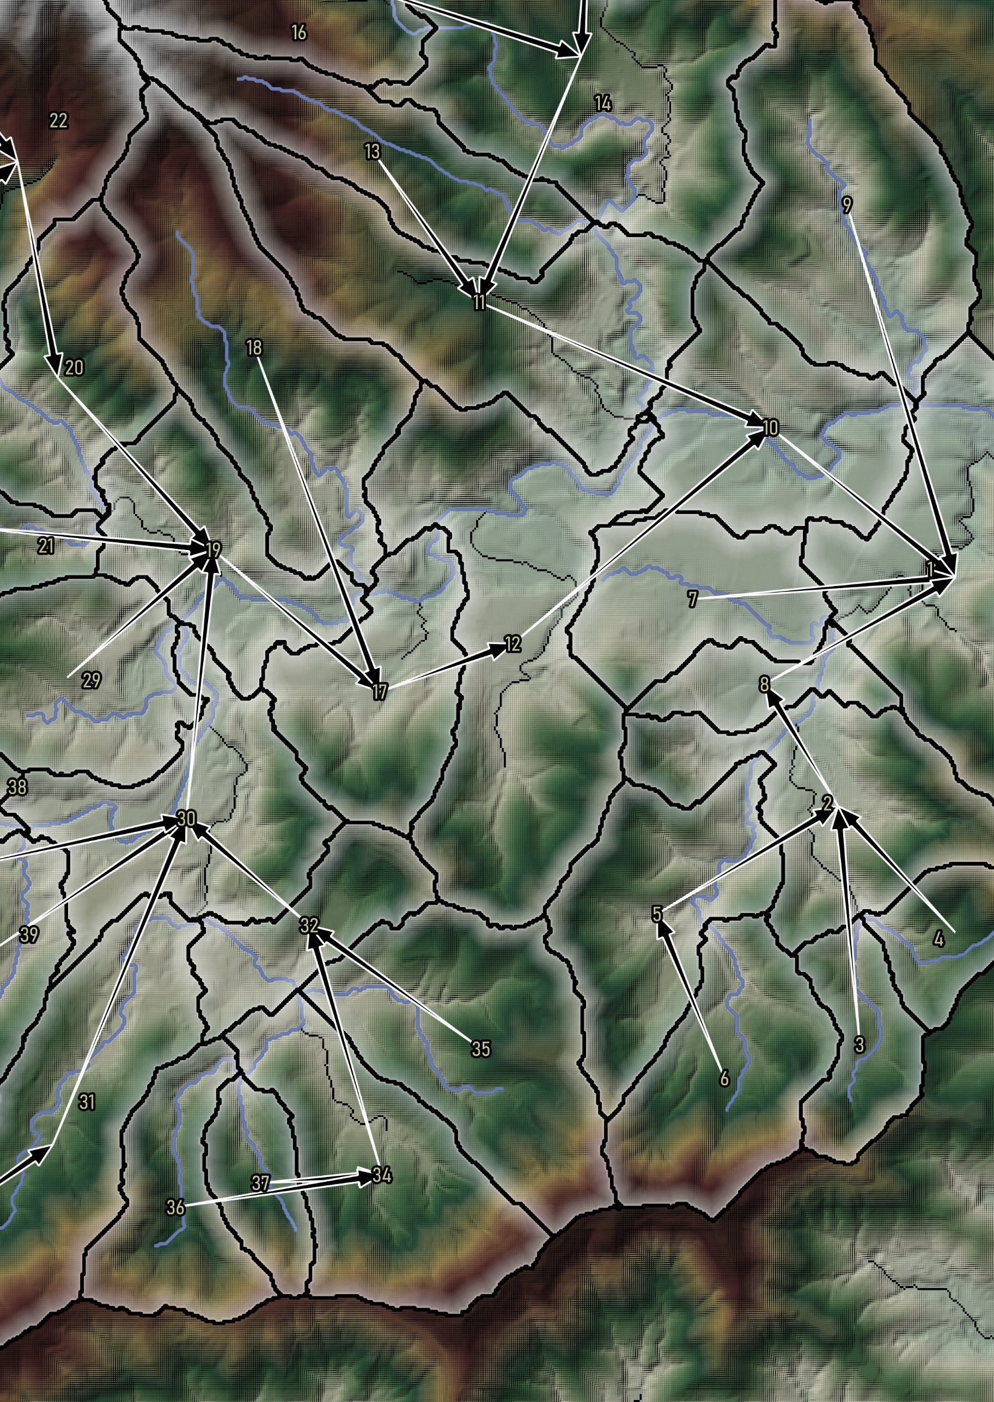

Mydro User Manual

Callan Schonrock, 2024

# Table of Contents

Table of Contents ii

1 Introduction 1

1.1 Background 1

1.2 Installation 1

2 QMydro User Manual 4

2.1 Overview 4

2.2 Algorithms 4

2.3 Hydraulic Enforcements 4

2.4 Catchment Characteristics 4

2.5 Inputs 5

2.6 Outputs 5

3 Mydro Hydrologic Processes 6

3.1 Overview 6

3.2 Upper Catchment 6

3.3 Catchment Routing 6

3.4 Channel Routing 7

4 Running Mydro 8

4.1 Overview 8

4.2 Mydro Control File 9

4.3 Routing Definition File 11

4.5 Subcatchment Characteristics File 12

# Introduction

## Background

This user manual serves as documentation for the software package Mydro (Mannings/Muskingum-Hydrology). The Mydro software package consists of the Runoff-Routing software (Mydro) and the QGIS plugin for spatial subcatchment management (QMydro). Mydro facilitates end-to-end hydrologic analysis, providing autocalibration methods, rainfall file management, and generation of TUFLOW-ready input files. Drawing inspiration from URBS (Don Carroll, 2009), Mydro has reworked each stage of runoff-routing to minimize global parameter sensitivity, where global parameters in Mydro are primarily utilized for fine-tuning.

This manual is intended to provide an overview to the hydrologic principals, model schematization, and guidance for conducting hydrologic analysis using Mydro.

## Installation

### QMydro

The QMydro package consists of the “QMydro.zip” file for QGIS plugin installable from the QGIS plugin manager as shown in Figure 1. After installation it will appear in the toolbar ribbons of the QGIS instance (Figure 2). On opening of the QMydro interface, required and optional inputs consists of:

* Elevation
* Outlets
* Carving vectors
* Target Subcatchment Size
* Output Files Directory

As shown in Figure 3, the QMydro utility can be run directly within QGIS, with an external command prompt called for computational analysis. On first run, a license key will be required to be entered, obtained from a HydroRepo subscription, subsequent runs will access the cached license key file, and complete the processing. It is recommended that all specified files be within the same coordinate reference system (CRS).

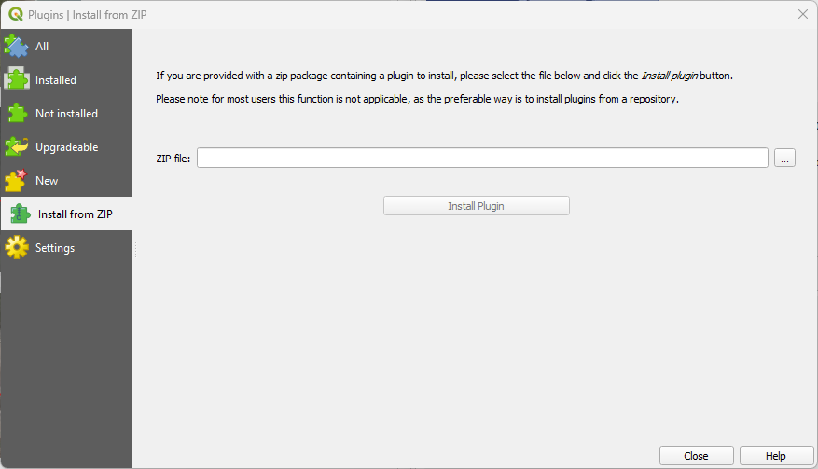

Figure : QMydro QGIS Installation

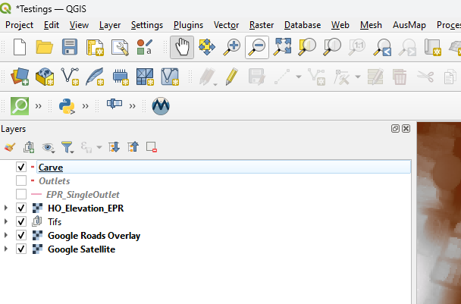

Figure : QMydro Toolbar Location

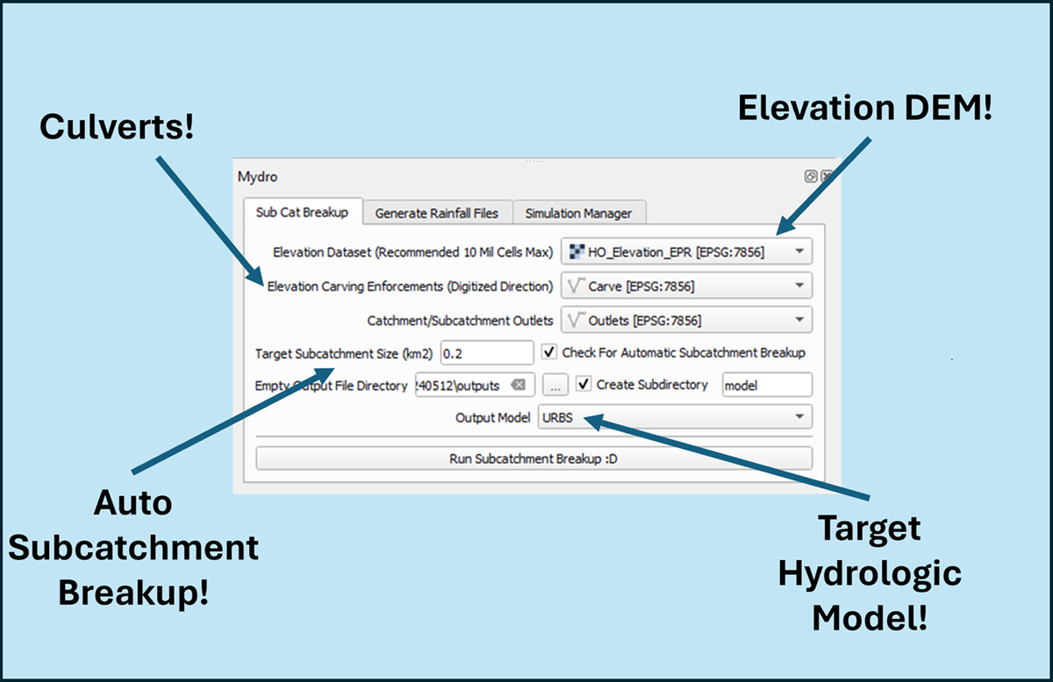

Figure : QMydro Plugin Usage

# QMydro User Manual

## Overview

The QMydro QGIS plugin is designed to estimate the required catchment characteristics for Mydro. The plugin uses raw Digital Elevation Models (DEMs) with user defined outlets, as vector line geometries. In addition to the subcatchment manager the QMydro plugin offers supplementary rainfall file generation for Australia by scraping ARR datahub, and a simulation manager designed to aid calibration efforts.

## Algorithms

The plugin employs the D8 algorithm to determine drainage direction. One notable drawback of the D8 algorithm is the “Snapping” of flow direction to a maximum of 22.5º. Alternative methods like that proposed of CatchmentSIM use a modification of Lea’s (1992) algorithm, where the drainage direction is defined as a vector where direction is defined from gradient. While this method can yield more precise results for flow path length and slope, the additional precision did not warrant the computational effort. Consequently, a bias correction was adopted where the eight-directional method is assumed to have an average angle of error of 11.25º, this results in an overestimation for cardinal directions of approximately 0.01959 units, and an underestimation for diagonal directions of 0.14956 units for dx-dy cells presentation of this concept is shown in Figure 4. It is acknowledged the average error approach does not account for weight of error, but is used as a simple approach to account for bias associated with the D8 algorithm.

Both channel and catchment slopes are estimated from the Equal Area slope, where no substantial slope is determined a minimum of 0.0005m/m is adopted.

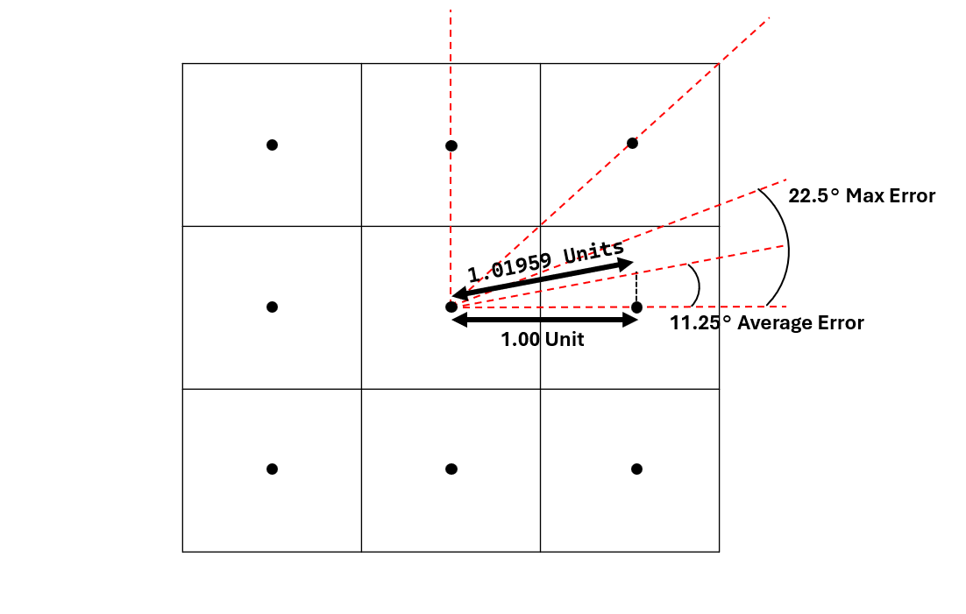

Figure : D8 Algorithm Bias Example

## Hydraulic Enforcements

The QMydro plugin offers optional user defined elevation “carving”, through vector line geometries to enforce flow through elevation embankments.

## Catchment Characteristics

Subcatchment characteristics as calculated from QMydro include:

* Subcatchment Area (km2)
* Main Channel Length (km)
* Characteristic Hill Length (km)
* Characteristic Hill Slope (m/m)
* Kappa (Dimensionless)
* Delta (Dimensionless)
* Subcatchment Routing Definition

Notably, there are significant differences in comparison to CatchmentSIM estimates of URBS parameters. The main channel length is defined as the maximum accumulation flow path to the subcatchment divide. An exception is made for self-contained subcatchments, where the main flow path is determined by upstream cells accounting for more than 12.5% of the subcatchment area. Similarly, Mydro’s hill slope is defined differently from CatchmentSIM’s estimation of Catchment Slope for URBS. The key distinction lies in the definition of hill length which is the distance from the top of the catchment to the main stream path.

The parameters of Kappa and Delta are calculated from the user defined subcatchment outlets which are used as channel cross-sections. It is recommended that the user defines outlets from lines that are representative of the channel cross section. Where Mydro is not confident that the user outlet represents a channel cross-section, kappa and delta are returned as zero. Where Mydro will interpret kappa and delta as default 0.3 and -0.3 respectively.

## Inputs

QMydro has several mandatory and optional inputs including:

* Elevation Raster (MANDATORY)
  + Catchment Elevation DEM.
  + GDAL Compatible formats.
  + Cloud Optimized Formats not supported.
* Carving Vector (OPTIONAL)
  + Vector layer (Line Shapefile).
  + Carves elevation from source DEM for hydraulic enforcement of Dams Embankments, Roads etc. Elevation enforcement is undertaken from start to end (digitized direction).
* Outlets (MANDATORY)
  + Vector layer (Line Shapefile).
  + Defines a catchment/subcatchment outlet, drawn over the cross section of the outlet location.
  + Multiple final outlets supported as well as self-contained outlets.
* Target Subcatchment Size (OPTIONAL)
  + Automatic breakup target subcatchment size, aimed to breakup at large stream branching.
* Empty Output File Directory
  + It is recommended that this be an empty output directory only containing superseded QMydro results to be overwritten.
* Output Model
  + Currently Supporting Mydro and URBS input files.

## Outputs

QMydro outputs several files that can be used for hydrological analysis including:

* Accumulation Raster
* Subcatchment Polygons
  + Subcatchment ID, Area, Upstream Area, Main Stream Length, Time of Concentration (Bransby Williams)
* Subcatchment Nodal Links
  + Centroid to Centroid
* Main Stream Path Vectors
* Mydro/URBS Build Files

# Mydro Hydrologic Processes

## Overview

Mydro has three stages to rainfall runoff routing. Including upper catchment routing, catchment routing and channel routing, each stage is approached differently and is summarized in following sections and as in Figure 4.

Figure : Mydro Hydrologic Processes Overview

## Upper Catchment

When rainfall is first introduced to the subcatchment, the rainfall is transformed into catchment storage from volume of water down a characteristic hill slope (HS) with a defined characteristic hill length (HL). Velocity of water down the catchment relief was estimated using the catchment relief flow velocities from Department of Transport Queensland.

Table : Catchment Relief Flow Velocities

|  |  |  |
| --- | --- | --- |
| Catchment Relief | Flow Velocity (km/h) | Flow Velocity (m/s) |
| Flat (0 – 0.015) | 1.1 | 0.31 |
| Rolling Hills (0.015 – 0.04) | 2.5 | 0.69 |
| Hilly (0.04 – 0.08) | 3.2 | 0.89 |
| Steep (0.08 – 0.15) | 5.4 | 1.50 |
| Mountainous (>0.15) | 10.8 | 3.00 |

## Catchment Routing

Catchment routing is defined as the non-linear storage-discharge relationship of:

$Q= \sqrt[m]{\frac{S_{catch} ×{(1+U)}^{2}}{β L_{Hill} ×{(1+F)}^{2}}}$ (1)

Where; -

$Q$ = Discharge (m3/s)

= Catchment Storage (m3)

= Characteristic Hill Length (m)

$β$ = Catchment Lag Parameter (Default $β$ = 10)

$m$ = Catchment Non-Linearity Parameter (Default $m$ = 0.6)

$U$ = Fraction Urbanized

$F$ = Fraction Forested

## Channel Routing

Channel Routing is defined as the storage-discharge relationship of:

$Q=\frac{1}{1-x}\left\{\frac{1}{α ∙ n}A\sqrt{S_{c}} \left[κ\ln{(A)}+δ\right]\right\}-xI$ (2)

Where; -

$Q$ = Discharge (m3/s)

= Alpha Parameter (Channel Lag)

$A$ = Conveyance Area (Estimated from Storage/Channel Length)

$S_{c}$ = Channel Slope (m/m)

$κ$ = Kappa Parameter (Estimated from channel characteristics Default $κ$ = 0.3)

$δ$ = Delta Parameter (Estimated from channel characteristics Default $δ$ = -0.3)

$n$ = Mannings Roughness (Default $n$ = 0.03)

$x$ = Translation Parameter (Default $x$ = 0.0)

$I$ = Upstream Channel Inflow (m3/s)

# Running Mydro

## Overview

Mydro can be run from a batch file, where the first argument should be the Mydro Control File to be run. A typical Mydro model folder structure is suggested to look like that shown below.

.

└── ModelName/

├── Model/

│ ├── Catchment/

│ │ ├── Outputs/

│ │ │ ├── _RoutingFile.vec

│ │ │ ├── _SubcatFile.csv

│ │ │ ├── acc.tif

│ │ │ ├── NodalLinks.*

│ │ │ ├── streams.*

│ │ │ └── SubCatchments.*

│ │ ├── ModelName_CarveLayer_01.*

│ │ ├── ModelName_OutletsLayer_01.*

│ │ └── ModelName_Elevation_01.tif

│ └── Rainfall/

│ ├── RF/

│ │ └── RF_~AEP~_~DUR~.csv

│ ├── Temporal_Patterns/

│ │ └── ...

│ ├── ARFs.csv

│ ├── data.txt

│ ├── IFD.csv

│ ├── initialLosses.csv

│ └── ModelName_IL_PreBurst_001.trd

├── Recorded/

│ └── ModelName_RecordedFlows.csv

└── Run/

├── E1a/

│ ├── ~AEP~_~DUR~_~ENS~.csv

│ └── ~AEP~_~DUR~_~ENS~_local.csv

├── C1a/

│ ├── C1a_Jan2021_Output.csv

│ └── C1a_Jan2021_Output_Local.csv

├── csv/

│ ├── ModelName_E1a_rf_dbase_01.csv

│ ├── ModelName_E1b_rf_PMP_dbase_01.csv

│ ├── ModelName_C1a_rf_Jan2021_505001_dbase_01.csv

│ ├── ModelName_C2a_rf_Feb2022_505001_dbase_01.csv

│ ├── ModelName_sq_dbase_01.csv

│ └── ModelName_sa_dbase_01.csv

├── run_allModels.bat

├── run_E.bat

├── run_C.bat

├── run_C1a.bat

├── ModelName_E1a_01.mcf

├── ModelName_E1b_PMP_01.mcf

├── ModelName_E2a_CC_01.mcf

├── ModelName_C1a_Jan2021_505001_01.mcf

├── ModelName_C2a_Feb2022_505001_01.mcf

## Mydro Control File

Mydro is controlled through a Mydro Control File (.mcf). Example format Mydro Control Files are shown below.

Single run Mydro Control File:

! Mandatory Args

run=single

cat=..\Model\catch\Outputs\_SubcatFile.csv

vec=..\Model\catch\Outputs\_RoutingFile.vec

rf_dbase=bc_dbase_single.csv

! Optional Args

IL=35

CL=1.0

sq_dbase=csv/sq_dbase.csv

sa_dbase=csv/rf_dbase.csv

X=0.0

N=1.0

a=1.0

b=10

m=0.6

output=Output.csv

Batch Processing Mydro Control File:

! Mandatory Args

run=batch

cat=..\Model\catch\Outputs\_SubcatFile.csv

vec=..\Model\catch\Outputs\_RoutingFile.vec

! Design Runs

rf_dbase=bc_dbase_des.csv

aep=063,039,020,010,005,002,001

dur=015m,020m,030m,045m,060m,090m,120m,180m,270m,360m

ensemble=E0,E1,E2,E3,E4,E5,E6,E7,E8,E9

! Optional Args

sq_dbase=csv/sq_dbase.csv

sa_dbase=csv/rf_dbase.csv

IL=..\Model\EPR_InitialLosses.csv

CL=1.7

X=0.1

N=1.0

a=1.0

b=10

m=0.6

! Optional Output File Names

outputDir=output

## Routing Definition File

The routing file format is used to define network routing order. The QMydro QGIS plugin can be used in aid to the development of the routing definition file. A typical Routing Definition file is shown below.

MODELNAME

RAIN #3

STORE.

RAIN #4

GET.

ROUTE THRU #2

ADD RAIN #2

STORE.

RAIN #5

STORE.

RAIN #6

GET.

ROUTE THRU #1

ADD RAIN #1

GET.

END OF CATCHMENT DATA.

## Subcatchment Characteristics File

The subcatchment characteristics file is used to define subcatchment characteristics used in the routing definition file. Required characteristics include:

* Index
* Area (km2)
* L – Main Channel Length (km2)
* Sc – Equal Area Channel Slope (m/m)
* HL – Characteristic Hill Length
* HS – Equal Area Characteristic Hill Slope (m/m)

Optional characteristics include:

* N – Mannings n (Default 0.03)
* k – Kappa (A value of zero defaults to 0.3)
* d – Delta (A value of zero defaults to -0.3)
* I – Fraction Impervious (1.0 is 100% Impervious)
* UL – Low Density Residential (1.0 is 100% Coverage)
* UM – Medium Density Residential (1.0 is 100% Coverage)
* UH – High Density Residential (1.0 is 100% Coverage)
* UF – Urban Forest (1.0 is 100% Coverage)

A typical subcatchment characteristics file is shown below utilizing all characteristics.

Index,Area,L,Sc,N,HL,HS,k,d,I,UL,UM,UH,UF

1,1.87,2.34,0.0005,0.020,0.72,0.003,0.33,-0.476,0.7,0.0,0.9,0.1,0.0

2,1.76,2.51,0.0038,0.035,0.39,0.014,0.00, 0.000,0.0,0.0,0.0,0.0,0.8

3,0.87,2.16,0.0119,0.040,0.29,0.025,0.50,-0.912,0.2,0.7,0.0,0.0,0.0

4,2.01,2.70,0.0100,0.040,0.66,0.016,0.65,-1.404,0.1,0.5,0.0,0.0,0.0

5,0.73,1.59,0.0024,0.040,0.37,0.020,0.49,-1.138,0.1,0.4,0.0,0.0,0.0

6,0.96,2.12,0.0080,0.035,0.24,0.016,0.40,-0.674,0.0,0.0,0.0,0.0,1.0

## Rainfall Database

The rainfall database file is similar to TUFLOW csv databases, where rainfall can be

###### Common QMydro Errors

This section is under construction, please email [callan.schonrock@hydrorepo.com](mailto:callan.schonrock@hydrorepo.com) on encountering errors and/or bugs.